COORDINATES
Pearson Edexcel – Thursday 4 June 2020 - Paper 2 (Calculator) Higher Tier
1.
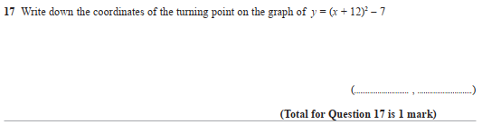
Pearson Edexcel - Tuesday 21 May 2019 - Paper 1 (Non-Calculator) Higher Tier
2.
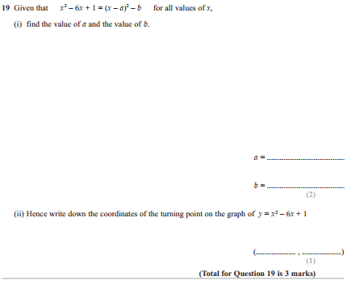

Pearson Edexcel - Tuesday 11 June 2019 - Paper 3 (Calculator) Higher Tier
3.
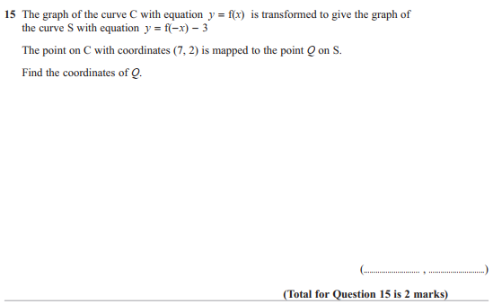

Pearson Edexcel - Tuesday 6 November 2018 - Paper 1 (Non-Calculator) Higher Tier
4.
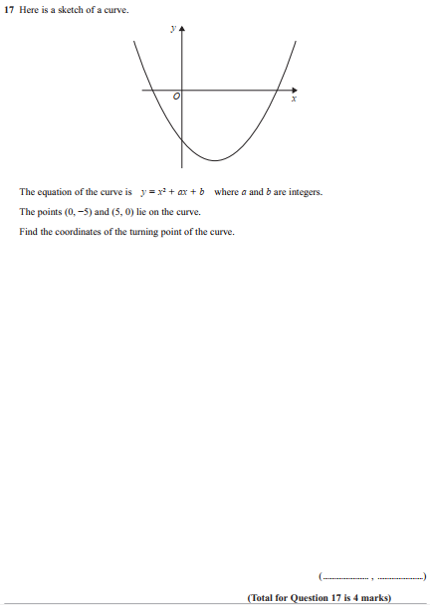

Pearson Edexcel - Thursday 8 November 2018 - Paper 2 (Calculator) Higher Tier
5.
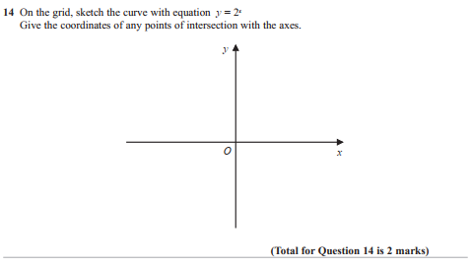
Pearson Edexcel - Thursday 8 November 2018 - Paper 2 (Calculator) Higher Tier
6.
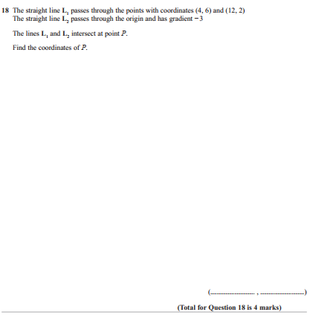

Pearson Edexcel - Monday 12 November 2018 - Paper 3 (Calculator) Higher Tier
7.
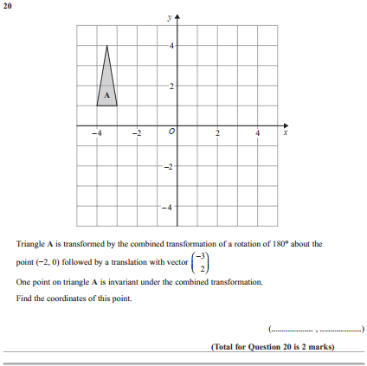

Pearson Edexcel - Thursday 24 May 2018 - Paper 1 (Non-Calculator) Higher Tier
8.
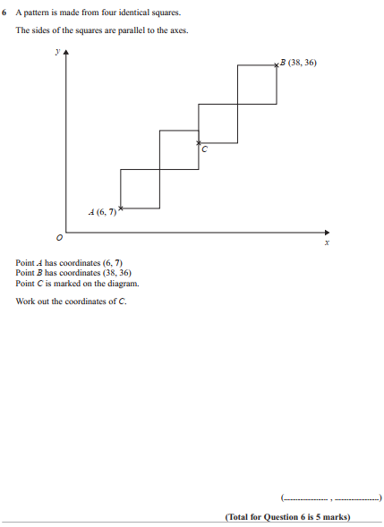

Pearson Edexcel - Tuesday 13 June 2017 - Paper 3 (Calculator) Higher Tier
9.
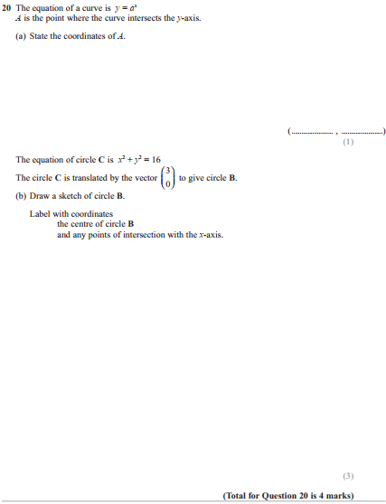

Pearson Edexcel - Specimen Papers Set 2 - Paper 3 (Calculator) Higher Tier
10.
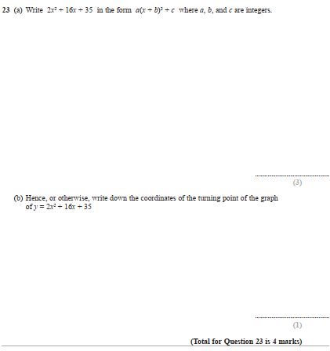
Pearson Edexcel - Specimen Papers Set 1 - Paper 3 (Calculator) Higher Tier
11.
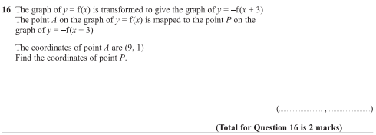

Pearson Edexcel - Sample Paper 2 - (Calculator) Higher Tier
12.
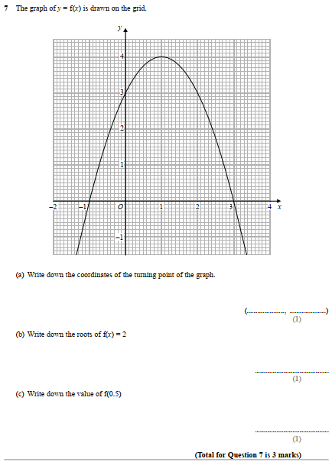
Pearson Edexcel - Thursday 26 May 2016 - Paper 1 (Non-Calculator) Higher Tier
13.
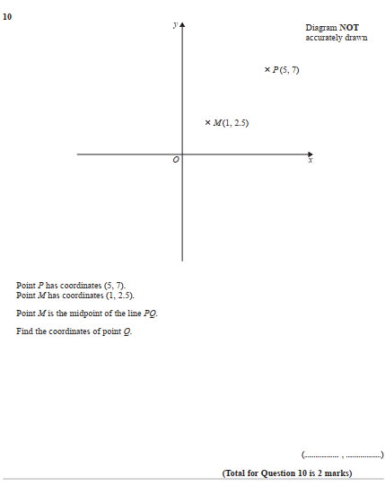

Pearson Edexcel - Thursday 4 June 2015 - Paper 1 (Non-Calculator) Higher Tier
14.
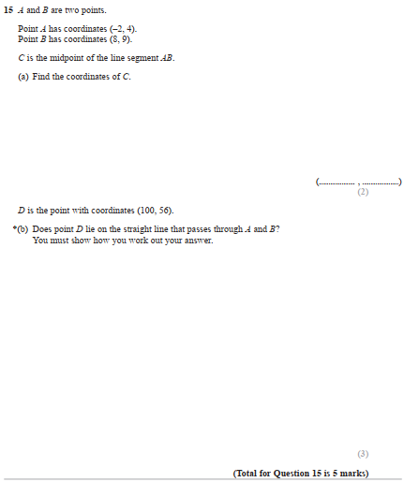

Pearson Edexcel - Thursday 4 June 2015 - Paper 1 (Non-Calculator) Higher Tier
15.
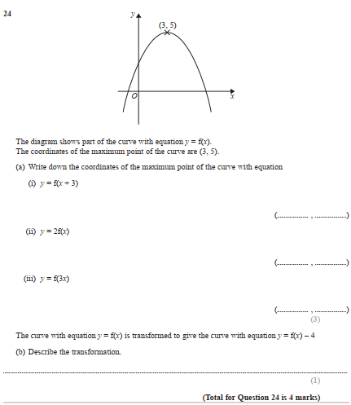

Pearson Edexcel - Monday 8 June 2015 - Paper 2 (Calculator) Higher Tier
16.
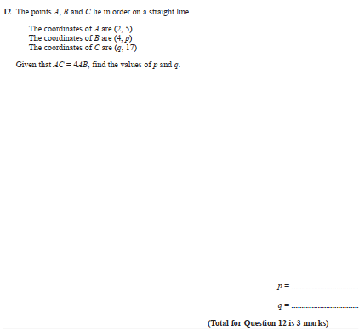

Pearson Edexcel - Wednesday 5 November 2014 - Paper 1 (Non-Calculator) Higher Tier
17.
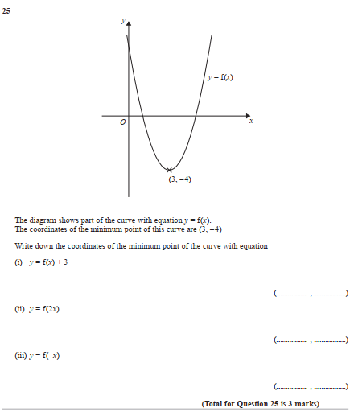

Pearson Edexcel - Monday 9 June 2014 - Paper 1 (Non-Calculator) Higher Tier
18.
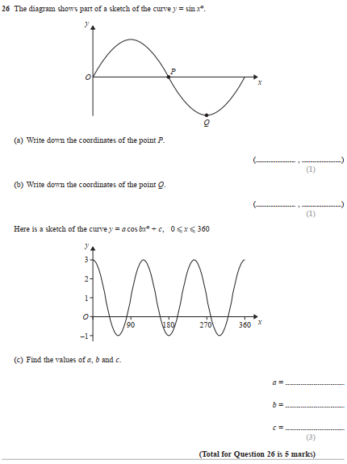

Pearson Edexcel - Friday 13 June 2014 - Paper 2 (Calculator) Higher Tier
19.
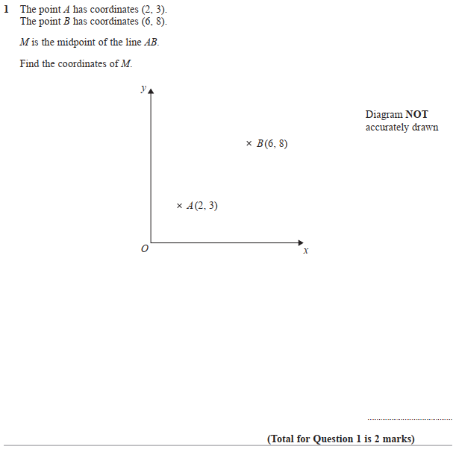

Pearson Edexcel - Friday 13 June 2014 - Paper 2 (Calculator) Higher Tier
20.
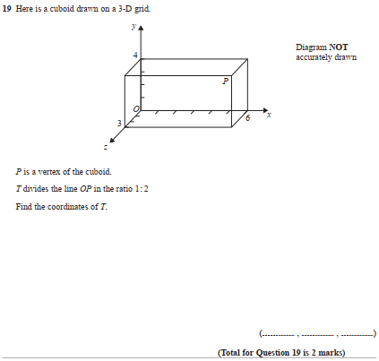

Pearson Edexcel - Wednesday 6 November 2013 - Paper 1 (Non-Calculator) Higher Tier
21.
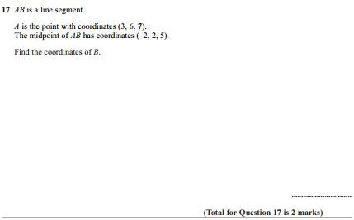

Pearson Edexcel - Tuesday 11 June 2013 - Paper 1 (Non-Calculator) Higher Tier
22.
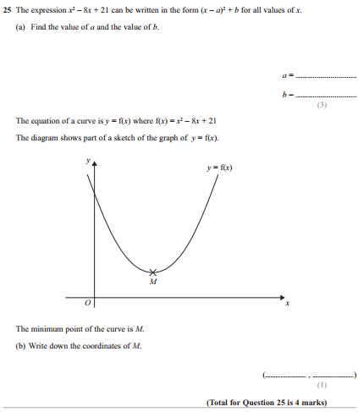

Pearson Edexcel - Tuesday 11 June 2013 - Paper 1 (Non-Calculator) Higher Tier
23.
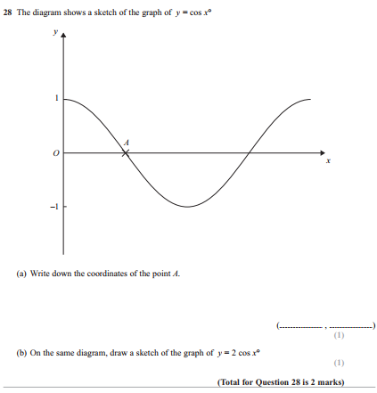

Pearson Edexcel - Tuesday 6 November 2012 - Paper 1 (Non-Calculator) Higher Tier
24.
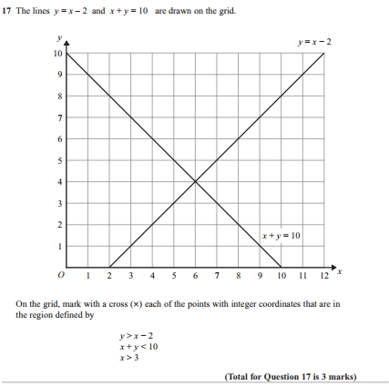

Pearson Edexcel - Tuesday 9 November 2010 - Paper 3 (Non-Calculator) Higher Tier
25.
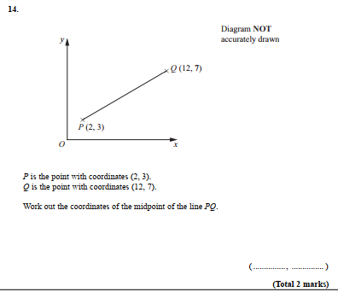

Pearson Edexcel - Friday 12 November 2010 - Paper 4 (Calculator) Higher Tier
26.
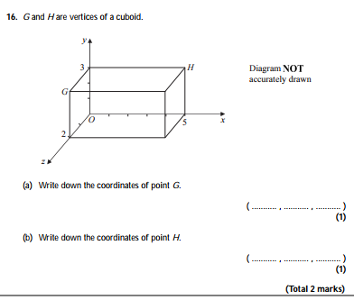
Pearson Edexcel - Friday 11 June 2010 - Paper 4 (Calculator) Higher Tier
27.
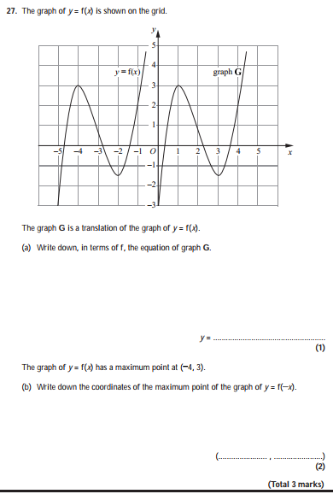

Pearson Edexcel - Thursday 5 November 2009 - Paper 3 (Non-Calculator) Higher Tier
28.
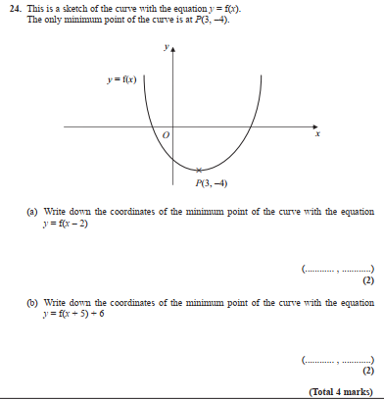
OCR GSCE – Thursday 5 November 2020 – Paper 5 (Non-Calculator) Higher Tier
29.
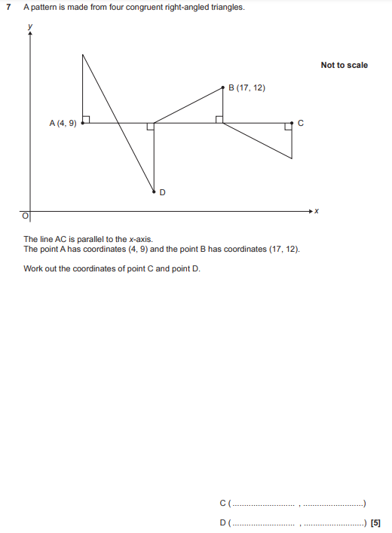

OCR GSCE – Tuesday 13 June 2017 – Paper 6 (Calculator) Higher Tier
30.
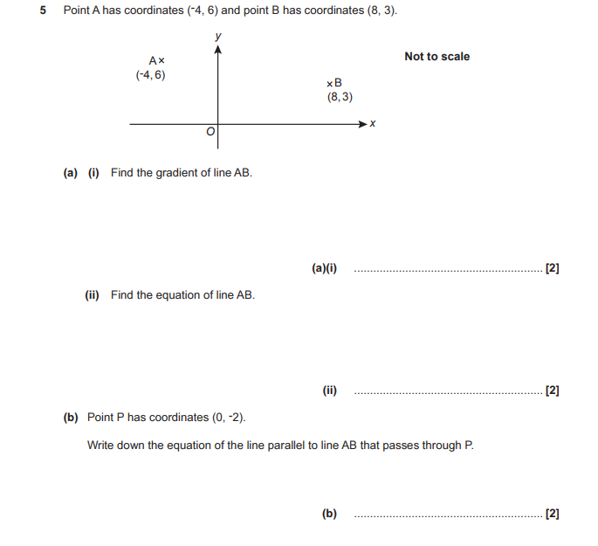

AQA GSCE – Thursday 8 November 2018 – Paper 2 (Calculator) Higher Tier
31.
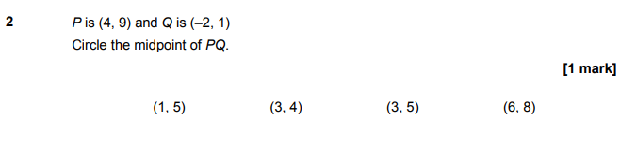
AQA GSCE – Monday 12 November 2018 – Paper 3 (Calculator) Higher Tier
32.
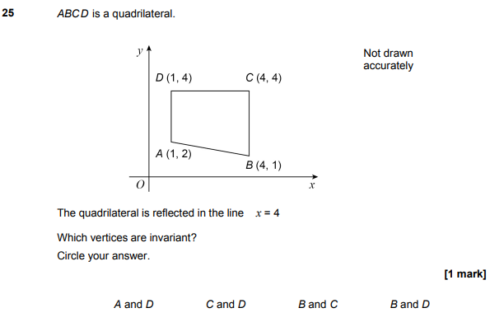

AQA GSCE – Monday 24 May 2018 – Paper 1 (Non - Calculator) Higher Tier
33.
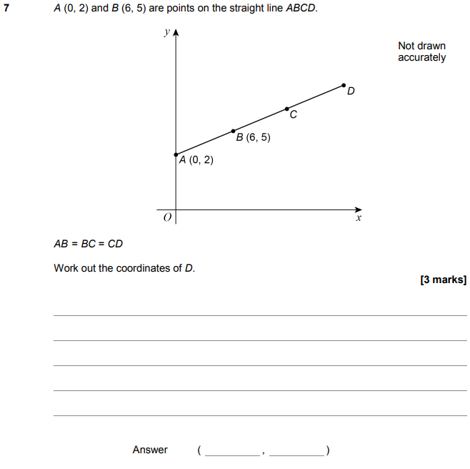

AQA GSCE – Tuesday 12 June 2018 – Paper 3 (Calculator) Higher Tier
34.
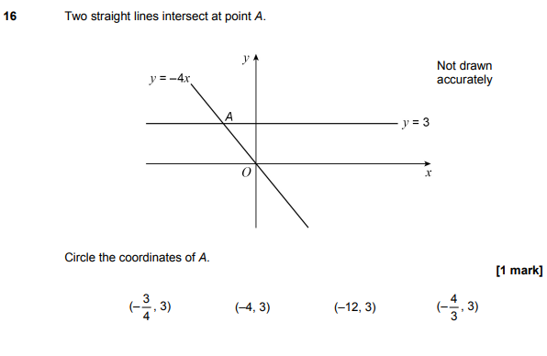

AQA GSCE – Thursday 2 November 2017 – Paper 1 (Non - Calculator) Higher Tier
35.
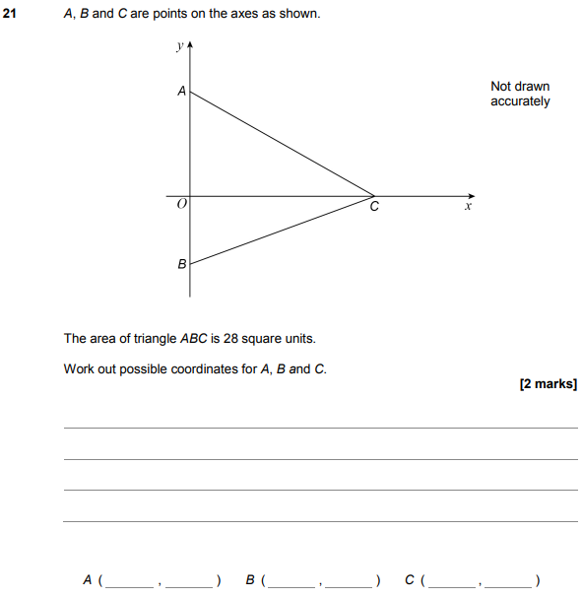

AQA GSCE – Thursday 2 November 2017 – Paper 1 (Non - Calculator) Higher Tier
36.
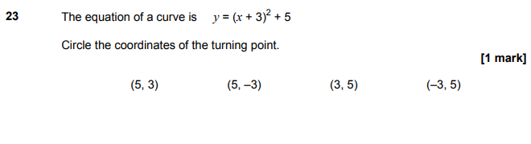
AQA GSCE – Thursday 6 November 2017 – Paper 2 (Calculator) Higher Tier
37.
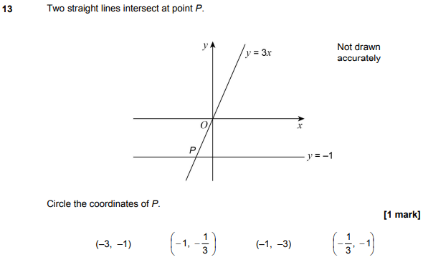

AQA GSCE – Thursday 8 June 2017 – Paper 2 (Calculator) Higher Tier
38.
AQA GSCE – Tuesday 13 June 2017 – Paper 3 (Calculator) Higher Tier
39.
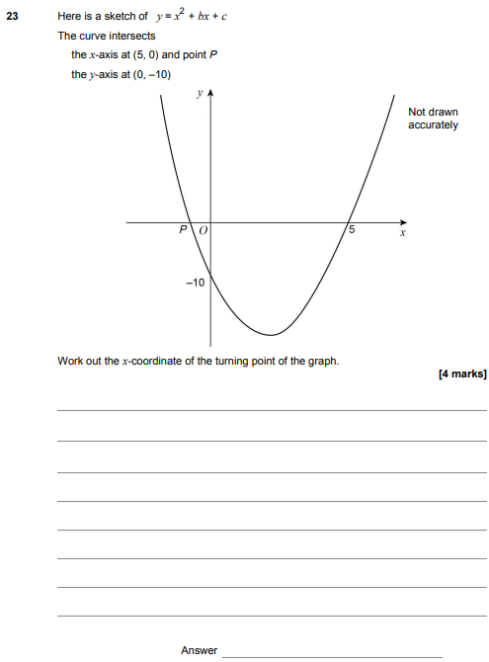

AQA GSCE – Sample Paper 3 (Calculator) Higher Tier
40.
